Design Thinking For Software Engineers
Lab-2
Mobile apps consume excessive data and batter
Name: Selva K Roll No:24BTCE197
1. Context
Mobile apps are widely used by students, professionals, and everyday users for communication, entertainment, and work. However, many apps consume excessive data and battery, leading to:
- Higher internet costs
- Faster battery drain
- Reduced productivity and mobility
2.Target users
- Students
Age:15-24
Digital literacy: medium to high
- Professionals
Age:25-45
Digital literacy: medium
- General users
Age:30-55
Digital literacy: medium
3.Initial Assumptions
- Many apps are poorly optimized, leading to excessive battery drain.
- Continuous background activity and auto-sync features consume large amounts of mobile data.
- Heavy multimedia content (videos, high-res images) accelerates both data usage and battery depletion.
- Users often lack awareness or control over app permissions/settings that impact resource consumption.

Output:
Assumption Id | Assumption
A1 | Students and professionals experience frequent battery/data exhaustion due to heavy app usage.
A2 | Optimized app design (lightweight, efficient coding) is a critical requirement to reduce resource drain.
A3 | High data/battery consumption is a result of background processes and auto-sync, not just user negligence.
A4 | Features that allow user control (data saver, battery optimization) are more effective than passive monitoring.

4.Interview Questions
- Tell me about the last time your phone battery drained quickly because of an app. What happened?
- How do you feel when an app uses too much mobile data in the background?
- What usually goes through your mind when you notice your phone heating up or slowing down due to app usage?
- What do you actually do when you see an app consuming excessive battery or data?
- What frustrates you most about current mobile apps in terms of battery and data usage?
- If you could change one thing to make apps more efficient with battery and data, what would it be?
5.Interview Notes and Quotes
Name: Prabhu
Age: 28
Occupation: Teacher
- Interview Notes:
○ He reported that several apps drained his phone battery within a few hours, even without active use.
○ He expressed frustration that background data usage consumed most of his monthly mobile data plan.
○ He observed that video streaming and social media apps were the biggest culprits for both data and battery drain.
○ He mentioned that constantly charging his phone during work was inconvenient and distracting.
○ He believed users should be given more transparent controls to manage app resource consumption.
- Quote: ○ “These apps eat up my battery and data silently, and I feel like I have no control.”
5.Interview Notes and Quotes
Name: Antony
Age: 20
Occupation: Undergraduate Student (B.Tech CSE)
- Interview Notes:
○ He reported that his phone battery drains quickly during online classes and coding practice sessions because of multiple apps running.
○ He expressed frustration that video lectures and project-related apps consume large amounts of mobile data, forcing him to recharge or top-up frequently.
○ He observed that social media apps running in the background worsen both data usage and battery drain.
○ He mentioned that carrying a power bank has become a necessity during college hours.
○ He felt that app developers focus more on adding new features than optimizing performance for students.
○ He believed lightweight versions of apps would help students manage resources better.
- Quote: ○ “As a student, I need my phone for learning, but these apps drain my battery and data faster than I can keep up.”
6.Empathy map
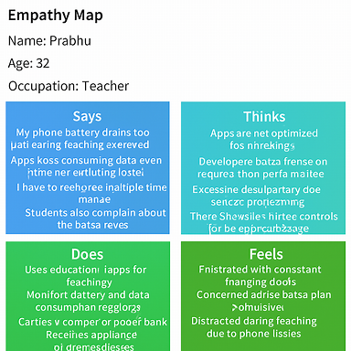
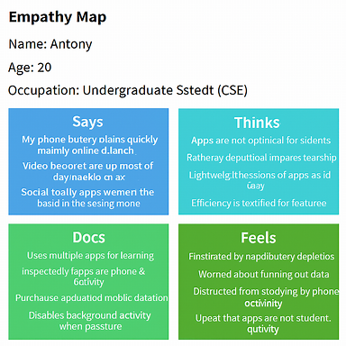
7. Validation of Assumptions
Assumption | Validated? | Reason from Interviews
Apps are poorly optimized, leading to battery drain | Yes | Users reported frequent charging and overheating. Research confirms inefficient app design increases power consumption.
Background activity and auto-sync consume excessive data | Yes | Interviewees noted data depletion even when apps weren’t actively used. Studies show background processes are major contributors.
Multimedia-heavy apps accelerate battery and data usage | Yes | Students and professionals cited video streaming and social media as top culprits. Technical benchmarks support high resource demand.
Users lack control over app resource settings | Partially | Some users adjust settings manually, but many are unaware of optimization tools. Interviews suggest demand for better transparency and control.

8. User Insights
- Users feel frustrated when apps drain battery during essential tasks like teaching or studying.
- Background data usage causes unexpected mobile data exhaustion, especially among students and professionals.
- Many users are unaware of optimization settings and feel helpless about controlling resource consumption.
- Frequent charging and overheating disrupt daily routines, leading to reduced trust in app efficiency.
9.User persona
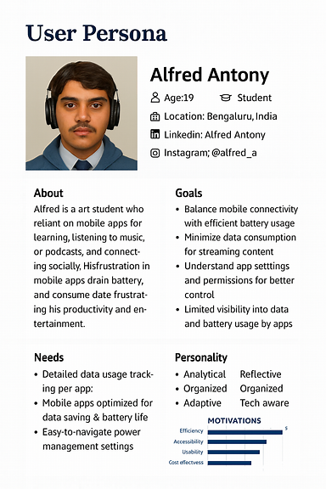
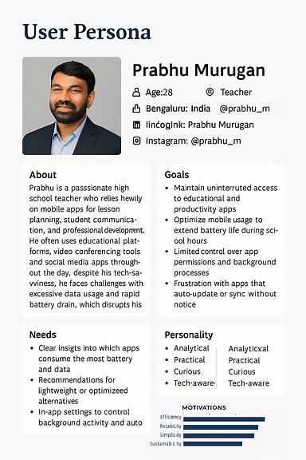
10.Translate insights to software needs
Insight | Software Requirement
Battery anxiety disrupts usage | Real-time battery consumption alerts
Data drain causes frustration | App-wise data usage breakdown
Background activity feels uncontrollable | Permission-based background activity toggles
Auto-sync drains resources silently | Manual sync scheduling options
Lack of transparency reduces trust | Visual dashboard for battery & data usage
No optimization guidance | Smart suggestions for low-data/battery alternatives
App overload leads to avoidance | Lightweight app mode or minimal UI toggle
Streaming apps dominate resources | Adaptive streaming quality based on battery/data
11.Reflection and Documentation
1. What surprised you during the interview?
Ans: What surprised me during the interview was that users were aware of how certain apps consume more data and battery, yet they continued using them due to lack of alternatives or awareness of optimization settings. Their tolerance for inconvenience was higher than expected, but frustration built up when it affected productivity or daily routines.
2. Which assumption was wrong?
Ans: The assumption that users always blame the app developers for battery and data issues was incorrect. Interviews revealed that users often blamed themselves for not managing settings or permissions properly. They expressed a desire for better guidance rather than just blaming the system.
3. How did empathy change your thinking?
Ans: Empathy changed my thinking by shifting focus from technical efficiency to user empowerment. Instead of assuming users just want faster apps, I began to understand their emotional need for control, clarity, and reassurance. The feeling of helplessness when apps drain resources silently was more impactful than the technical issue itself.
4. How will this affect your software design approach?
Ans: This will affect my software design approach by emphasizing transparency, user control, and contextual feedback. I will prioritize features that help users monitor and manage data and battery usage easily, and design interfaces that communicate clearly without overwhelming them.

